**Datalogger AirCore RUG**

The data logger is used for measuring and controlling the Air core. During the flight the Air core will be filled with air. The data that is measured during the flight will be logged on a micro SD card. The data logger is based on the Arduino Nano with a homemade board.

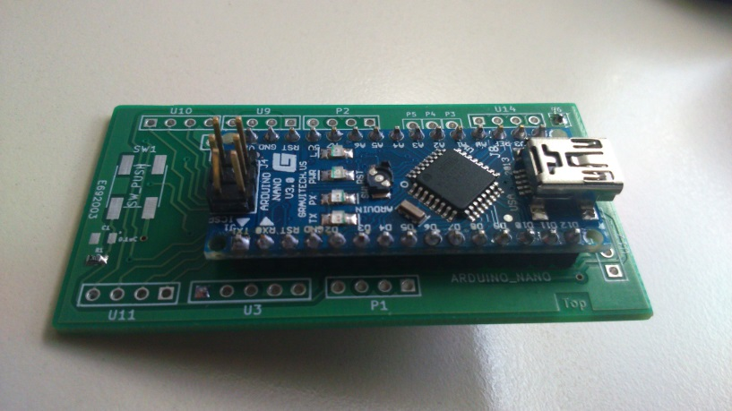

There are several things that has to be done during the flight. When the air core has been landed, the coil has to be closed automatically. This can be done by the automatic value showing in figure, described in section below. To decide when the coil has to be closed can be done on pressure measurement or/and GPS location. Both can be used, for the Pressure measurement, a pressure sensor is placed on the board. And for the GPS, an external connection is made for connecting the GPS module. The GPS module can also be used for logging the Position of the air core. During the flight the temperature of the coil is measured on 6 differed places. To know when the measurement has been done, there is a real time clock on board. This clock will give the date and time, which can be programmed. There are also possibilities to connect devices on a I2C bus or SPI bus(max. 3). If the three digital I/O pin aren’t used for the SPI bus, then these pins can be used as digital I/O pin. For example: to give a pulse to activated the automatic value. When the I²C connection is not used, then these two pins can be used as analog I/O pins. The board has also an extra three analog I/O pins for read or write an analog signal. For example to activated a radiometrix.

**- - Bottom of the D.A.R. - -**

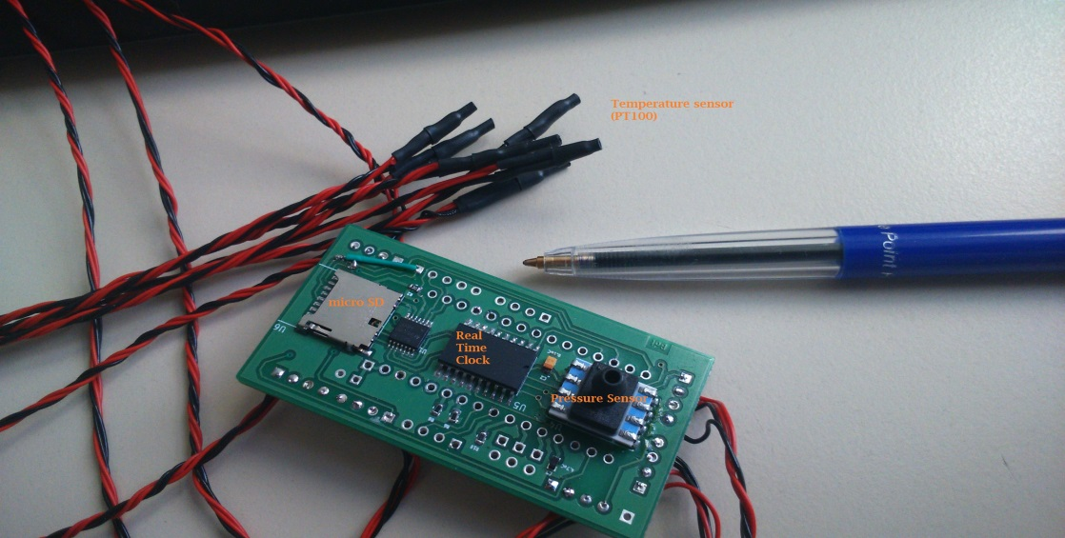

**Real time measurement.**

The time measurement is done with the real time IC DS3234 from Dallas semiconductors. The IC is an extremely accurate SPI bus RTC. The IC will be communicated and programmed through SPI bus with the Arduino. The time and date will be logged : DD-MM-YY HH:MM:SS.

**Pressure measurements.**

The Pressure measurement is done with the Honeywell TruStability HSC Silicon Pressure Sensor. Pressure sensor is used for detecting landing and communicated with PSI bus. Accuracy ±0.25% and pressure range 0-15 PSI.

**Micro SD card.**

The data will be logged on a micro SD card. The communication is done with the SPI bus.

**- - Top of the D.A.R - -**

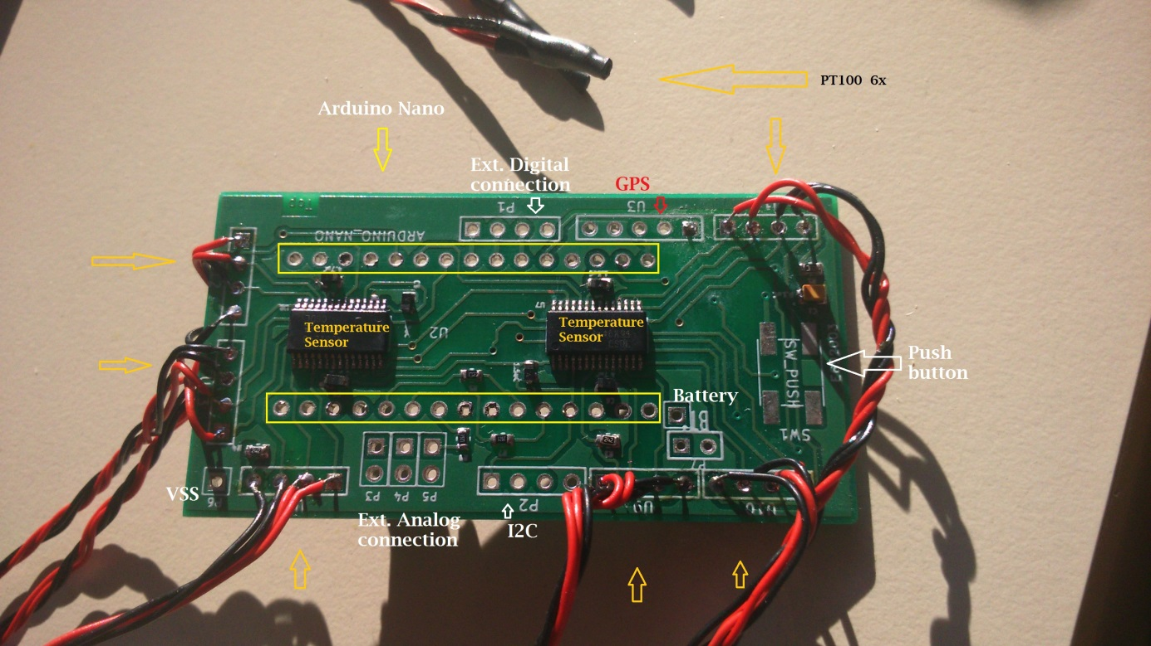

**Temperature measurement.**

The temperature measurement is done with the IC ADS1248, 24-bit Analog-to-Digital Converters for Temperature Sensors. There are 6 places on the board to connect a PT100 sensor to measure the Coil temperature. The measurement is done by a three(four) point measurement, because of this method, there can only be 3 sensor on one IC. For 6 sensors, there are two IC on board. The communication of the IC is done with the SPI bus. The sensor is the world´s smallest platinum thin-film temperature sensor from Innovative Sensor Technology. Tolerance class A (0. 15°C)

**GPS connection**

The GSP sensor can be connected to P1, the serial bus connection of the board.

**Ext. I**²**C connection.**

Several devices, that communicate with an I²C bus can be connected to P2. P2 is an I²C bus connection.

**Ext. connection**

There are three analog connection (P3, P4 and P5) on the board, they can be used as analog input or output. 10 bit resolution.

On the board are also three digital i/o connection (P1). These pins can be used for extra connections on the SPI bus, active the automatic value with one external interrupt or input ready sensor.

SW-Push is space for a push button, this can be used for example to activate the data logger.

**Automatic value**

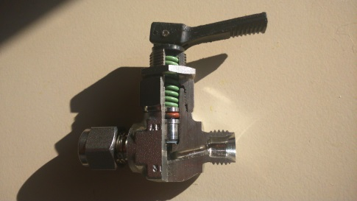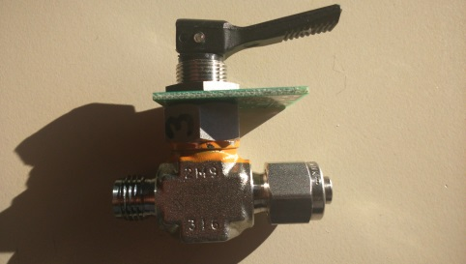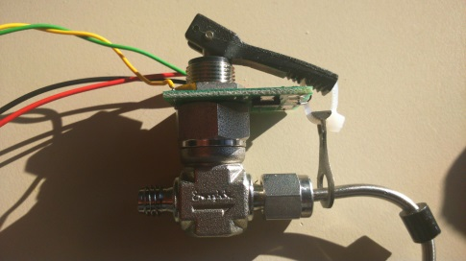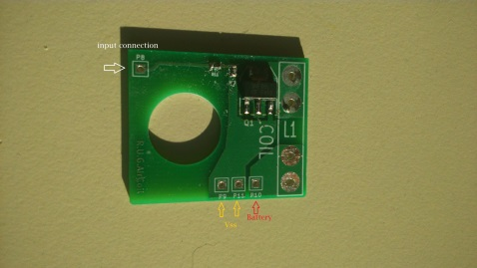

The board for the automatic value is based on a 9 Volt battery and a digital input.